**Set up Arduino IDE on computer**

1. Download Arduino IDE application
   * <https://support.arduino.cc/hc/en-us/articles/360019833020-Download-and-install-Arduino-IDE>
2. Get Arduino code and libraries from GitHub (<https://github.com/EdFClayton/Clarity-Sensor>)
3. Go to File/Preferences
   * Add the following link into the “Additional boards manager URLs:” text box
   * <https://adafruit.github.io/arduino-board-index/package_adafruit_index.json>
   * Click OK

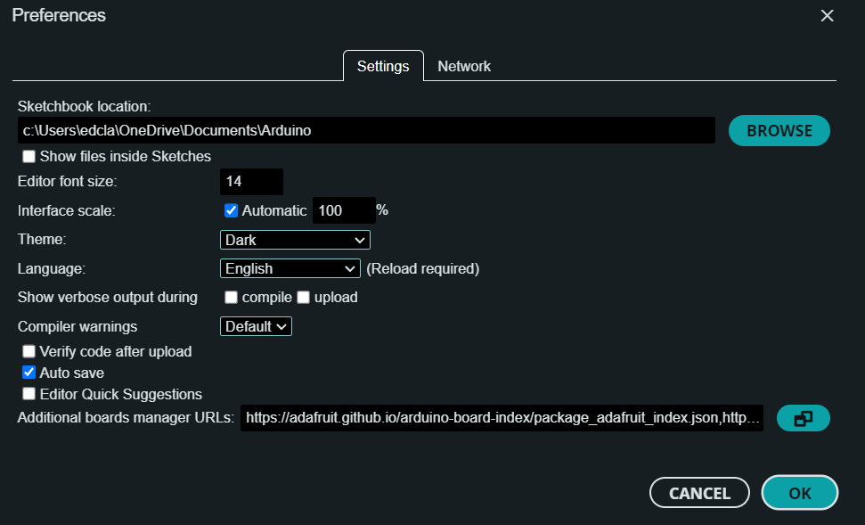

1. Add Adafruit board, by clicking board manager 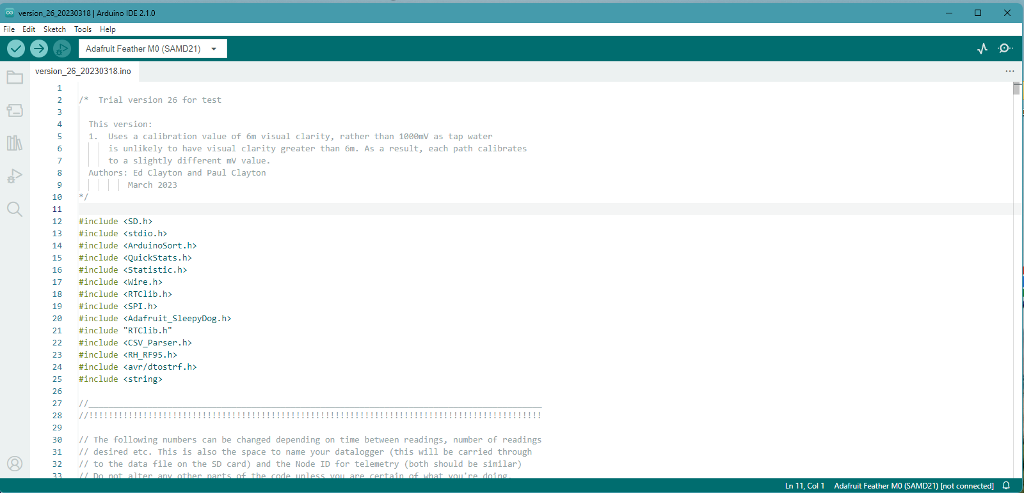 and searching for the Adafruit Feather M0 board (the board within the sensor). Select “Adafruit SAMD Boards” INSTALL button.
2. Select specific board, by clicking “Tools”>”Board”>”Adafruit SAMD Boards”>”Adafruit Feather M0 (SAMD21)”
3. Verify the code  to check for issues. Pay attention to where errors occur (the app will stop when it detects an issue and highlight it).
4. Ensure that all necessary libraries are installed. To add new libraries, click the library manager tab , and search for specific libraries.
   * Unique and hard to find code libraries are on GitHub, download them as zip folders (<https://github.com/EdFClayton/Clarity-Sensor/tree/main/code%20libraries>)
   * To add these libraries, click “Sketch”>”Include Library”>”Add .Zip library”
   * All other libraries can be added by searching the library manager within the Arduino IDE
5. Continuing verifying code  until there are no more errors.



Library Managerager

Board Managerager

Verify

Necessary Librariesager